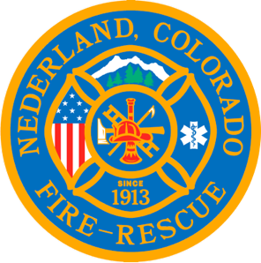

Nederland Fire Protection District Board of Directors Regular Meeting Agenda
May 24th 2023

** This meeting is being recorded **

Roll Call
Iain Irwin-Powell –
Todd Wieseler -
Guy Falsetti –
Jess McElvain –
Russ Panneton –
Interim Chief Schmidtmann -

Announce Quorum & Call Meeting to Order @

Approve the meeting agenda

Acceptance of previous meeting minutes
April 19, 2023

Oaths of Office
Guy Falsetti
Todd Wieseler
Savannah Ames

Outgoing Board Members Speeches

Recess Public Meeting for Filing of Oaths @

Resume Public Meeting @

Roll Call
Jess McElvain
Guy Falsetti
Todd Wiesler
Russ Panneton
Savannah Ames

Announce Quorum & Call Meeting to Order @
Motions to Select Members to Board Positions
President/Chair
Vice President
Treasurer
Secretary

Public Statements, Comments or Questions
(Please state name and if in district or out of district for the record)
Name District

Treasurer’s Report

Chief’s Report

Old Business
Update on hiring process

New Business
Water system reserves
Board bylaws - review

Special Executive Session

Special Meeting Conclusions

Public Statements, Comments or Questions
(Please state name and if in district or out of district for the record)

Any other business

Next Meeting June 21st @ 7pm

Adjourn the meeting @

