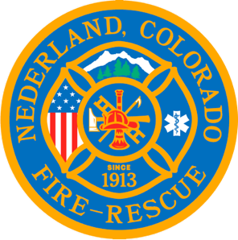

Nederland Fire Protection District Board of Directors Special Meeting Agenda
October 17, 2023

** This meeting is being recorded **

Roll Call
Guy Falsetti -
Todd Wiesler –
Russ Panneton -
Bob Sheehan -
Ryan Keeler -

Chief Schmidtmann -

Announce Quorum & Call Meeting to Order @

Public Statements, Comments or Questions
(Please state name and if in district or out of district for the record)
Name District

Approve the meeting agenda

New Business
Approve Resolution 2023-12 regarding Proposition HH

Special Executive Session

Special Meeting Conclusions

Public Statements, Comments or Questions
(Please state name and if in district or out of district for the record)

Any other business

Next Meeting November 15th @ 7pm

Adjourn the meeting @

