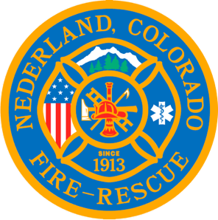

Nederland Fire Protection District Board of Directors Regular Meeting Agenda
February 21, 2024

** This meeting is being recorded **

Roll Call
Guy Falsetti -
Todd Wieseler –
Russ Panneton -
Bob Sheehan
Ryan Keeler

Chief Schmidtmann -

Announce Quorum & Call Meeting to Order @

Public Statements, Comments or Questions
(Please state name and if in district or out of district for the record)
Name District

Approve the meeting agenda

Acceptance of previous meeting minutes

Treasurer’s Report

Chief’s Report

Old Business

New Business
- Fire Chief performance evaluation process and timing – Lucy and Guy
- Quote for new carpet – Sherry
- Indian Peaks Radio Club request for meeting location.

Special Executive Session

Special Meeting Conclusions

Public Statements, Comments or Questions
(Please state name and if in district or out of district for the record)

Any other business

Next Regular Board Meeting March 20, 2024 @ 7pm

Adjourn the meeting @

